

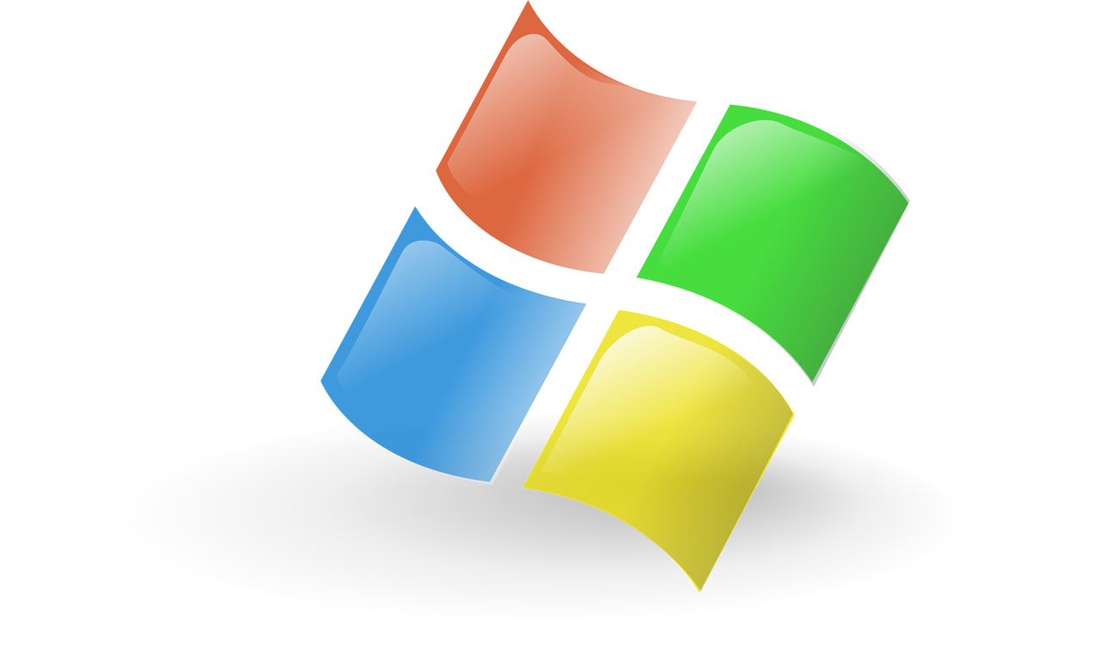
MS – office 2013
With Practical Assignments
English Edition

MS – Office 2013
With Practical Assignments

- Computer Fundamentals. Windows 7
- Microsoft World 2013. Microsoft Exel 2013
- Microsoft Powerpoint 2013. Microsoft Access 2013
- Microsoft Outlook 2013. Internet

